THỬ NGHIỆM SỐ
“MULTISTEP METHOD RELAXED FOR A CLASS OF STRUCTURED STRANGENESS-FREE DAEs”
Ví dụ 22: 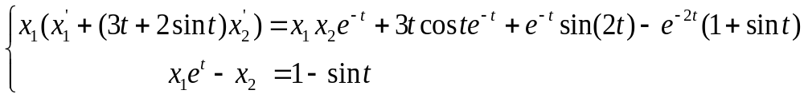 trên khoảng 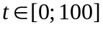. Điều kiện đầu được cho 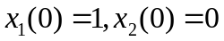, nghiệm chính xác của bài toán là: 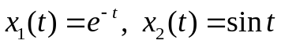. 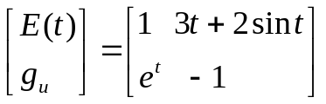.
Table 01: Kết quả số cho Ví dụ 22 bằng phương pháp ẩn: Standard ILM methods và ILM-New methods.
h = 0.1 | Standard AdamsM2 method |  | AdamsM2 method
h = 0.1 | A-errors for X₁ | E-order for X₁ | A-errors for X₁ | E-order for X₁
h  h/2 h/4  h/8  h/16  h/32  h/64 | 2.2511e-02  1.0474e-01  2.9403e-01  5.1611e-01  7.0058e-01  8.2642e-01  9.0049e-01 | -2.2181e+00  -1.4892e+00  -8.1171e-01  -4.4087e-01  -2.3833e-01  -1.2382e-01 | 1.2436e-04  1.9798e-05  2.8070e-06  3.7451e-07  4.8386e-08  6.1498e-09  7.7517e-10 | 2.6511e+00  2.8182e+00  2.9059e+00  2.9523e+00  2.9760e+00  2.9880e+00
 | A-errors for X₂ | E-order for X₂ | A-errors for X₂ | E-order for X₂
h  h/2 h/4  h/8  h/16  h/32  h/64 | 1.2291e+00  1.0022e+00  1.0009e+00  1.0011e+00  1.0004e+00  1.0000e+00  1.0000e+00 | 2.9432e-01  1.8871e-03  -1.9203e-04  9.5134e-04  5.7595e-04  -6.1434e-05 | 5.2062e-03  6.1336e-04  7.3442e-05  8.9494e-06  1.1033e-06  1.3692e-07  1.7050e-08 | 3.0854e+00  3.0621e+00  3.0367e+00  3.0200e+00  3.0104e+00  3.0055e+00
h = 0.1 | Standard Trapezoidal method |  | New-Trapezoidal method
h = 0.1 | A-errors for X₁ | E-order for X₁ | A-errors for X₁ | E-order for X₁
h  h/2 h/4  h/8  h/16  h/32  h/64 | 2.9016e-04  7.2838e-05  1.8240e-05  4.5611e-06  1.1404e-06  2.8510e-07  7.1274e-08 | 1.9941e+00  1.9976e+00  1.9996e+00  1.9999e+00  2.0000e+00  2.0000e+00 | 1.1140e-03  2.7830e-04  6.9570e-05  1.7391e-05  4.3477e-06  1.0869e-06  2.7173e-07 | 2.0011e+00  2.0001e+00  2.0001e+00  2.0000e+00  2.0000e+00  2.0000e+00
 | A-errors for X₂ | E-order for X₂ | A-errors for X₂ | E-order for X₂
h  h/2 h/4  h/8  h/16  h/32  h/64 | 1.3414e-03  3.3816e-04  8.4701e-05  2.1185e-05  5.2970e-06  1.3243e-06  3.3107e-07 | 1.9880e+00  1.9973e+00  1.9993e+00  1.9998e+00  2.0000e+00  2.0000e+00 | 4.0641e-02  9.8255e-03  2.4360e-03  6.0776e-04  1.5186e-04  3.7960e-05  9.4898e-06 | 2.0483e+00  2.0120e+00  2.0029e+00  2.0007e+00  2.0002e+00  2.0000e+00

h | Method | Errors in X₁ | Errors in X₂ | Time in second
h = 0.01 | Standard BDF2 method | 1.1350e-05 | 8.8701e-05 | 26.868650
h = 0.01 | Trapezoidal method | 1.1130e-05 | 3.8887e-04 | 21.464517
h = 0.01 | HELM3 method | 1.8100e-04 | 6.7148e-03 | 0.147197
h = 0.005 | Standard BDF2 method | 2.8780e-06 | 1.7862e-05 | 43.103896
h = 0.005 | Trapezoidal method | 2.7825e-06 | 9.7185e-05 | 41.461294
h = 0.005 | HELM3 method | 4.6263e-05 | 1.6684e-03 | 0.232118
h = 0.001 | Standard BDF2 method | 1.1644e-07 | 5.7681e-07 | 213.040622
h = 0.001 | Trapezoidal method | 1.1130e-07 | 3.8870e-06 | 200.680630
h = 0.001 | HELM3 method | 1.8837e-06 | 6.6230e-05 | 1.083216

Ví dụ 40: 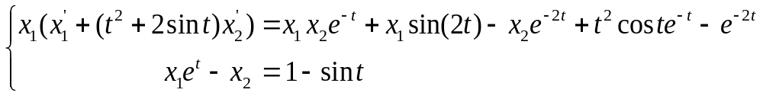 trên khoảng . Điều kiện đầu được cho , nghiệm chính xác của bài toán là: . Jacobian 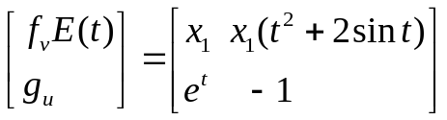.
Table 41: Kết quả số cho Ví dụ 40 bằng phương pháp Đa bước ẩn.

h = 0.1 | Standard AdamsM2 method |  | AdamsM2 method
h = 0.1 | A-errors for X₁ | E-order for X₁ | A-errors for X₁ | E-order for X₁
h  h/2 h/4  h/8  h/16  h/32  h/64 | 2.4108e-02  1.1599e-01  3.0893e-01  5.2862e-01  7.0023e-01  8.2125e-01  8.9778e-01 | -2.2664e+00  -1.4133e+00  -7.7494e-01  -4.0559e-01  -2.3000e-01  -1.2854e-01 | 1.7904e-04  2.6066e-05  3.5069e-06  4.5459e-07  5.7860e-08  7.2979e-09  9.1635e-10 | 2.7801e+00  2.8939e+00  2.9475e+00  2.9739e+00  2.9870e+00  2.9935e+00
 | A-errors for X₂ | E-order for X₂ | A-errors for X₂ | E-order for X₂
h  h/2 h/4  h/8  h/16  h/32  h/64 | 1.0094e+00  1.0016e+00  1.0004e+00  1.0000e+00  1.0000e+00  1.0000e+00  1.0000e+00 | 1.1171e-02  1.7218e-03  5.1257e-04  -2.2992e-05  2.2060e-05  1.5535e-05 | 2.9539e-03  4.2612e-04  5.7168e-05  7.4010e-06  9.4137e-07  1.1870e-07  1.4901e-08 | 2.7933e+00  2.8980e+00  2.9494e+00  2.9749e+00  2.9875e+00  2.9939e+00
h = 0.1 | Standard Trapezoidal method |  | New-Trapezoidal method
h = 0.1 | A-errors for X₁ | E-order for X₁ | A-errors for X₁ | E-order for X₁
h  h/2 h/4  h/8  h/16  h/32  h/64 | 3.8211e-04  9.5993e-05  2.4020e-05  6.0064e-06  1.5017e-06  3.7543e-07  9.3857e-08 | 1.9930e+00  1.9987e+00  1.9997e+00  1.9999e+00  2.0000e+00  2.0000e+00 | 5.6239e-04  1.4162e-04  3.5468e-05  8.8708e-06  2.2180e-06  5.5450e-07  1.3863e-07 | 1.9896e+00  1.9974e+00  1.9994e+00  1.9998e+00  2.0000e+00  2.0000e+00
 | A-errors for X₂ | E-order for X₂ | A-errors for X₂ | E-order for X₂
h  h/2 h/4  h/8  h/16  h/32  h/64 | 4.9948e-03  9.3984e-04  2.3506e-04  5.8769e-05  1.4692e-05  3.6731e-06  9.1827e-07 | 2.4099e+00  1.9994e+00  1.9999e+00  2.0000e+00  2.0000e+00  2.0000e+00 | 4.1464e-02  9.6467e-03  2.3921e-03  5.9725e-04  1.4921e-04  3.7302e-05  9.3251e-06 | 2.1038e+00  2.0118e+00  2.0019e+00  2.0010e+00  2.0000e+00  2.0001e+00

Table 42: Kết quả số cho Ví dụ 40 bằng phương pháp: Standard HELM3 methods và HELM3-New methods; .
h = 0.1 | Standard HELM3 method |  | HELM3 method
h = 0.1 | A-errors for X₁ | E-order for X₁ | A-errors for X₁ | E-order for X₁
h  h/2 h/4  h/8  h/16  h/32  h/64 | Inf  Inf  Inf  Inf  Inf  Inf  Inf | NaN  NaN  NaN  NaN  NaN  NaN | 7.0299e-03  1.7812e-03  4.6210e-04  1.3254e-04  3.5384e-05  9.1342e-06  2.3200e-06 | 1.9806e+00  1.9466e+00  1.8018e+00  1.9053e+00  1.9538e+00  1.9771e+00
 | A-errors for X₂ | E-order for X₂ | A-errors for X₂ | E-order for X₂
h  h/2 h/4  h/8  h/16  h/32  h/64 | Inf  Inf  Inf  Inf  Inf  Inf  Inf | NaN  NaN  NaN  NaN  NaN  NaN | 5.0690e-01  1.6461e-01  4.3243e-02  1.0642e-02  2.6082e-03  6.4366e-04  1.5975e-04 | 1.6226e+00  1.9286e+00  2.0227e+00  2.0286e+00  2.0187e+00  2.0104e+00
h = 0.1 | Standard HEAB2 method |  | HEAB2 method
h = 0.1 | A-errors for X₁ | E-order for X₁ | A-errors for X₁ | E-order for X₁
h  h/2 h/4  h/8  h/16  h/32  h/64 | 1.6382e-03  4.4307e-04  1.1530e-04  2.9422e-05  7.4314e-06  1.8675e-06  4.6808e-07 | 1.8865e+00  1.9421e+00  1.9704e+00  1.9852e+00  1.9926e+00  1.9963e+00 | 2.1236e-03  5.3508e-04  1.5512e-04  4.1550e-05  1.0738e-05  2.7285e-06  6.8762e-07 | 1.9887e+00  1.7864e+00  1.9005e+00  1.9521e+00  1.9766e+00  1.9884e+00
 | A-errors for X₂ | E-order for X₂ | A-errors for X₂ | E-order for X₂
h  h/2 h/4  h/8  h/16  h/32  h/64 | 4.8464e-02  8.6534e-03  1.6669e-03  3.5294e-04  8.0214e-05  1.9049e-05  4.6368e-06 | 2.4856e+00  2.3761e+00  2.2396e+00  2.1375e+00  2.0741e+00  2.0386e+00 | 1.8806e-01  5.0423e-02  1.2489e-02  3.0663e-03  7.5707e-04  1.8793e-04  4.6807e-05 | 1.8991e+00  2.0135e+00  2.0261e+00  2.0180e+00  2.0102e+00  2.0054e+00
h = 0.1 | Standard BDF2 method |  | BDF2 method
h = 0.1 | A-errors for X₁ | E-order for X₁ | A-errors for X₁ | E-order for X₁
h  h/2 h/4  h/8  h/16  h/32  h/64 | 1.1818e-03  3.3710e-04  9.0028e-05  2.3256e-05  5.9098e-06  1.4895e-06  3.7391e-07 | 1.8097e+00  1.9048e+00  1.9528e+00  1.9764e+00  1.9882e+00  1.9941e+00 | 1.8445e-03  4.3438e-04  1.1408e-04  3.1860e-05  8.4089e-06  2.1595e-06  5.4715e-07 | 2.0862e+00  1.9289e+00  1.8403e+00  1.9218e+00  1.9612e+00  1.9807e+00
 | A-errors for X₂ | E-order for X₂ | A-errors for X₂ | E-order for X₂
h  h/2 h/4  h/8  h/16  h/32  h/64 | 5.0592e-02  7.7243e-03  1.4187e-03  2.9266e-04  6.5424e-05  1.5397e-05  3.7290e-06 | 2.7114e+00  2.4448e+00  2.2773e+00  2.1614e+00  2.0872e+00  2.0458e+00 | 2.7387e-01  4.7085e-02  1.0508e-02  2.5010e-03  6.1068e-04  1.5092e-04  3.7514e-05 | 2.5402e+00  2.1638e+00  2.0709e+00  2.0340e+00  2.0166e+00  2.0083e+00

h | Method | Errors in X₁ | Errors in X₂ | CPU time in second
h = 0.01 | BDF2 method | 2.0839e-05 | 1.5855e-03 | 21.421982
h = 0.01 | Trapezoidal method | 5.6776e-06 | 3.8214e-04 | 22.228353
h = 0.01 | HEAB2 method | 2.6950e-05 | 1.9532e-03 | 0.132953
h = 0.01 | HELM3 method | 8.7105e-05 | 6.7637e-03 | 0.137856
h = 0.005 | BDF2 method | 5.4400e-06 | 3.8904e-04 | 42.000943
h = 0.005 | Trapezoidal method | 1.4195e-06 | 9.5500e-05 | 47.173216
h = 0.005 | HEAB2 method | 6.9173e-06 | 4.8319e-04 | 0.245548
h = 0.005 | HELM3 method | 2.2940e-05 | 1.6610e-03 | 0.250559
h = 0.001 | BDF2 method | 2.2520e-07 | 1.5334e-05 | 207.753183
h = 0.001 | Trapezoidal method | 5.6783e-08 | 3.8195e-06 | 213.561841
h = 0.001 | HEAB2 method | 2.8247e-07 | 1.9145e-05 | 1.123430
h = 0.001 | HELM3 method | 9.5568e-07 | 6.5257e-05 | 1.139160

Ví dụ 31: DAEs: 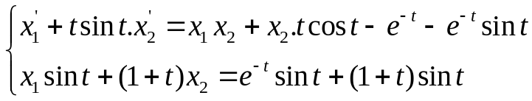 trên khoảng 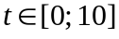. Điều kiện đầu được cho , nghiệm chính xác của bài toán là: . 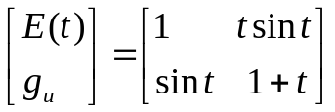
Ví dụ 32: DAEs: 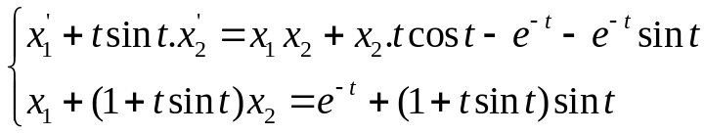 trên khoảng . Điều kiện đầu được cho , nghiệm chính xác của bài toán là: . 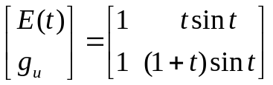
Ví dụ 33: DAEs: 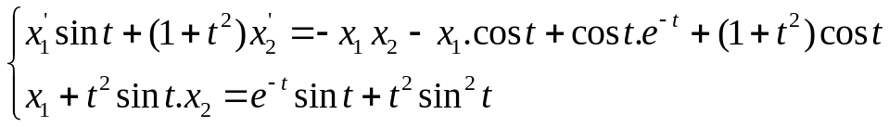 trên khoảng . Điều kiện đầu được cho , nghiệm chính xác của bài toán là: . 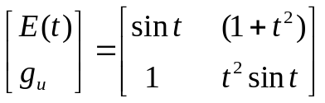

Phương pháp hiển ổn định chặt
Phương pháp Adams-Bashforth 2 bước (AdamsB2) 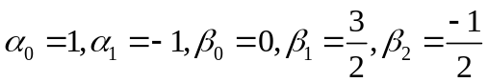. Đa thức đặc trưng thứ hai 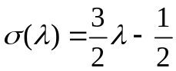 có nghiệm 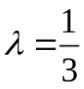.

Table 02: Kết quả số cho Ví dụ 22 bằng phương pháp bán hiển: Standard HELM methods và HELM methods (New).

h = 0.1 | Standard HELM3 method |  | HELM3 method
h = 0.1 | A-errors for X₁ | E-order for X₁ | A-errors for X₁ | E-order for X₁
h
h/2 h/4
h/8
h/16
h/32
h/64
 | A-errors for X₂ | E-order for X₂ | A-errors for X₂ | E-order for X₂
h
h/2 h/4
h/8
h/16
h/32
h/64
h = 0.1 | Trapezoidal method |  | New-Trapezoidal method
h = 0.1 | A-errors for X₁ | E-order for X₁ | A-errors for X₁ | E-order for X₁
h
h/2 h/4
h/8
h/16
h/32
h/64
h/128
 | A-errors for X₂ | E-order for X₂ | A-errors for X₂ | E-order for X₂
h
h/2 h/4
h/8
h/16
h/32
h/64
h/128

Table 2: Kết quả số cho Ví dụ 1 trong khoảng thời giạn 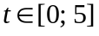
bằng phương pháp bán hiển: Standard HE-LM và HELM-New.

 | h = 0.1 | Standard HELM3 method |  | HELM3 method
 | h = 0.1 | A-errors for X₁ | E-order for X₁ | A-errors for X₁ | E-order for X₁
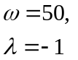 | h  h/2 h/4  h/8  h/16  h/32  h/64 h/128 | 6.4086e+039  3.2791e+077  3.4717e+147  6.8643e+275  Inf  Inf  Inf  Inf | -1.2527e+002  -2.3262e+002  -4.2619e+002  -Inf  NaN  NaN  NaN | 3.9278e-001  9.7735e-002  2.4333e-002  6.0681e-003  1.5150e-003  3.7849e-004  9.4588e-005  2.3643e-005 | 2.0068e+000  2.0060e+000  2.0036e+000  2.0019e+000  2.0010e+000  2.0005e+000  2.0003e+000
 |  | A-errors for X₂ | E-order for X₂ | A-errors for X₂ | E-order for X₂
 | h  h/2 h/4  h/8  h/16  h/32  h/64 h/128 | 2.5532e+037  1.3064e+075  1.3832e+145  2.7348e+273  Inf  Inf  Inf  Inf | -1.2527e+002  -2.3262e+002  -4.2619e+002  -Inf  NaN  NaN  NaN | 4.8087e-003  1.2526e-003  3.1946e-004  8.0651e-005  2.0260e-005  5.0773e-006  1.2708e-006  3.1790e-007 | 1.9407e+000  1.9712e+000  1.9859e+000  1.9930e+000  1.9965e+000  1.9983e+000  1.9991e+000
 | h = 0.1 | Standard HELM3 method |  | HELM3 method
 | h = 0.1 | A-errors for X₁ | E-order for X₁ | A-errors for X₁ | E-order for X₁
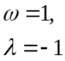 | h  h/2 h/4  h/8  h/16  h/32  h/64 h/128 | 5.4401e+025  4.9420e+052  1.2705e+107  4.0372e+216  Inf  3.9026e+303  5.0015e+302  Inf | -8.9554e+001  -1.8075e+002  -3.6376e+002  -Inf  Inf  2.9640e+000  -Inf | 1.1790e-002  2.9682e-003  7.4330e-004  1.8590e-004  4.6480e-005  1.1620e-005  2.9051e-006  7.2628e-007 | 1.9899e+000  1.9976e+000  1.9994e+000  1.9998e+000  2.0000e+000  2.0000e+000  2.0000e+000
 |  | A-errors for X₂ | E-order for X₂ | A-errors for X₂ | E-order for X₂
 | h  h/2 h/4  h/8  h/16  h/32  h/64 h/128 | 9.0668e+024  8.2367e+051  2.1175e+106  6.7287e+215  Inf  1.4127e+303  2.6564e+302  Inf | -8.9554e+001  -1.8075e+002  -3.6376e+002  -Inf  Inf  2.4109e+000  -Inf | 4.8087e-003  1.2526e-003  3.1946e-004  8.0651e-005  2.0260e-005  5.0773e-006  1.2708e-006  3.1790e-007 | 1.9407e+000  1.9712e+000  1.9859e+000  1.9930e+000  1.9965e+000  1.9983e+000  1.9991e+000

Table 3: Kết quả số cho Ví dụ 2 trong khoảng thời giạn 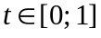
bằng phương pháp Bán hiển: Standard HE-LM và HELM-New.

h = 0.1 | HELM3 method |  | New HELM3 method
h = 0.1 | A-errors for X₁ | E-order for X₁ | A-errors for X₁ | E-order for X₁
h  h/2 h/4  h/8  h/16  h/32  h/64 h/128 | 5.9440e-001  1.1594e+004  7.6938e+013  5.5496e+034  4.6734e+077  Inf  1.7831e+154  1.7591e+154 | -1.4252e+001  -3.2628e+001  -6.9289e+001  -1.4259e+002  -Inf  Inf  1.9602e-002 | 1.3440e-003  4.6067e-004  1.3304e-004  3.5634e-005  9.2171e-006  2.3437e-006  5.9090e-007  1.4835e-007 | 1.5447e+000  1.7919e+000  1.9005e+000  1.9509e+000  1.9755e+000  1.9878e+000  1.9939e+000
 | A-errors for X₂ | E-order for X₂ | A-errors for X₂ | E-order for X₂
h  h/2 h/4  h/8  h/16  h/32  h/64 h/128 | 2.1867e-001  4.2650e+003  2.8304e+013  2.0416e+034  1.7192e+077  Inf  1.1106e+154  1.3861e+154 | -1.4252e+001  -3.2628e+001  -6.9289e+001  -1.4259e+002  -Inf  Inf  -3.1966e-001 | 8.1517e-004  2.9998e-004  8.9614e-005  2.4429e-005  6.3761e-006  1.6285e-006  4.1151e-007  1.0343e-007 | 1.4422e+000  1.7431e+000  1.8751e+000  1.9378e+000  1.9691e+000  1.9846e+000  1.9923e+000
h = 0.1 | Trapezoidal method |  | New-Trapezoidal method
h = 0.1 | A-errors for X₁ | E-order for X₁ | A-errors for X₁ | E-order for X₁
h  h/2 h/4  h/8  h/16  h/32  h/64 h/128 | 1.1104e-003  2.7781e-004  6.9467e-005  1.7368e-005  4.3419e-006  1.0855e-006  2.7137e-007  6.7843e-008 | 1.9989e+000  1.9997e+000  1.9999e+000  2.0000e+000  2.0000e+000  2.0000e+000  2.0000e+000 | 1.4269e-004  3.5817e-005  8.9662e-006  2.2432e-006  5.6083e-007  1.4021e-007  3.5053e-008  8.7633e-009 | 1.9942e+000  1.9981e+000  1.9989e+000  1.9999e+000  2.0000e+000  2.0000e+000  2.0000e+000
 | A-errors for X₂ | E-order for X₂ | A-errors for X₂ | E-order for X₂
h  h/2 h/4  h/8  h/16  h/32  h/64 h/128 | 4.0850e-004  1.0220e-004  2.5555e-005  6.3892e-006  1.5973e-006  3.9933e-007  9.9832e-008  2.4958e-008 | 1.9989e+000  1.9997e+000  1.9999e+000  2.0000e+000  2.0000e+000  2.0000e+000  2.0000e+000 | 9.9649e-005  2.5002e-005  6.2562e-006  1.5657e-006  3.9144e-007  9.7861e-008  2.4465e-008  6.1164e-009 | 1.9948e+000  1.9987e+000  1.9985e+000  1.9999e+000  2.0000e+000  2.0000e+000  2.0000e+000
h = 0.1 | AdamsM2 method |  | New AdamsM2 method
h = 0.1 | A-errors for X₁ | E-order for X₁ | A-errors for X₁ | E-order for X₁
h  h/2 h/4  h/8  h/16  h/32  h/64 h/128 | 6.7805e-005  2.9912e-005  5.6921e-002  2.7183e+000  2.7183e+000  2.7183e+000  2.7183e+000  2.7183e+000 | 1.1807e+000  -1.0894e+001  -5.5776e+000  -2.5972e-011  0  0  0 | 5.7700e-005  7.9094e-006  1.0339e-006  1.3212e-007  1.6696e-008  2.0985e-009  2.6304e-010  3.2888e-011 | 2.8669e+000  2.9355e+000  2.9682e+000  2.9842e+000  2.9921e+000  2.9960e+000  2.9996e+000
 | A-errors for X₂ | E-order for X₂ | A-errors for X₂ | E-order for X₂
h  h/2 h/4  h/8  h/16  h/32  h/64 h/128 | 2.4944e-005  1.1568e-005  2.0940e-002  1.0012e+000  1.0012e+000  1.0007e+000  1.0004e+000  1.0002e+000 | 1.1085e+000  -1.0822e+001  -5.5793e+000  -5.3239e-005  7.5578e-004  4.4051e-004  2.3798e-004 | 2.4009e-005  3.3478e-006  4.4174e-007  5.6716e-008  7.1841e-009  9.0397e-010  1.1337e-010  1.4204e-011 | 2.8423e+000  2.9220e+000  2.9613e+000  2.9809e+000  2.9905e+000  2.9952e+000  2.9967e+000

Table 4: Kết quả số cho Ví dụ 1 trong khoảng thời giạn
bằng PP bán hiển Adams-Bashforth 2: Standard HEAdamsB2 và HEAdamsB2-New.

 | h = 0.1 | Standard HEAdamsB2 method |  | New HEAdamsB2 method
 | h = 0.1 | A-errors for X₁ | E-order for X₁ | A-errors for X₁ | E-order for X₁
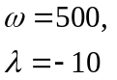 | h  h/2 h/4  h/8  h/16  h/32 | 7.6728e+003  1.5426e+003  2.3678e+002  4.5114e+001  7.9986e+000  1.7311e+000 | 2.3144  2.7037  2.3919  2.4958  2.2081 | 5.9881e+002  3.6268e+000  8.1849e-001  1.9137e-001  4.6168e-002  1.1333e-002 | 7.3673  2.1477  2.0966  2.0514  2.0264
 | h = 0.1 | A-errors for X₂ | E-order for X₂ | A-errors for X₂ | E-order for X₂
 | h  h/2 h/4  h/8  h/16  h/32 | 5.6315e+000  2.6995e+000  1.1105e+000  3.6472e-001  9.5553e-002  2.2827e-002 | 1.0608  1.2815  1.6063  1.9324  2.0655 | 4.9126e-001  5.5650e-002  1.1082e-002  2.5782e-003  6.2142e-004  1.5251e-004 | 3.1420  2.3282  2.1038  2.0527  2.0267
 | h = 0.1 | A-errors for X₁ | E-order for X₁ | A-errors for X₁ | E-order for X₁
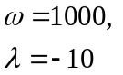 | h  h/2 h/4  h/8  h/16  h/32 | 3.0974e+004  8.5843e+003  1.3381e+003  2.1454e+002  3.7629e+001  7.1954e+000 | 1.8513  2.6816  2.6408  2.5113  2.3867 | 1.1974e+003  7.2177e+000  1.6289e+000  3.8085e-001  9.1879e-002  2.2553e-002 | 7.3741  2.1477  2.0966  2.0514  2.0264
 | h = 0.1 | A-errors for X₂ | E-order for X₂ | A-errors for X₂ | E-order for X₂
 | h  h/2 h/4  h/8  h/16  h/32 | 8.3969e+000  4.1721e+000  1.8456e+000  6.7552e-001  1.9462e-001  4.7047e-002 | 1.0091  1.1767  1.4500  1.7953  2.0485 | 4.9126e-001  5.5650e-002  1.1082e-002  2.5782e-003  6.2142e-004  1.5251e-004 | 3.1420  2.3282  2.1038  2.0527  2.0267
 | h = 0.1 | A-errors for X₁ | E-order for X₁ | A-errors for X₁ | E-order for X₁
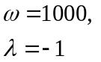 | h  h/2 h/4  h/8  h/16  h/32 | 1.2686e+004  3.9026e+003  6.9180e+002  1.2075e+002  2.7188e+001  6.6567e+000 | 1.7007  2.4960  2.5184  2.1509  2.0301 | 2.3926e+000  5.8114e-001  1.4316e-001  3.5526e-002  8.8484e-003  2.2080e-003 | 2.0416  2.0212  2.0107  2.0054  2.0027
 | h = 0.1 | A-errors for X₂ | E-order for X₂ | A-errors for X₂ | E-order for X₂
 | h  h/2 h/4  h/8  h/16  h/32 | 2.5366e+000  1.0294e+000  3.1591e-001  7.7975e-002  1.8379e-002  4.5139e-003 | 1.3011  1.7042  2.0184  2.0849  2.0256 | 1.6262e-003  3.9478e-004  9.7244e-005  2.4130e-005  6.0101e-006  1.4997e-006 | 2.0424  2.0214  2.0108  2.0054  2.0027

